**Company Overview**

The company selected is called ‘Everyone Everywhere Rentals’ (imaginary company for the sake of this project); it is a chain company with multiple in-person locations that provide car rental services to people across the country. The line of operation would be vehicle rental. Everyone Everywhere Rentals is not a real company and has been created for the purpose of this project.

In this system, data will be collected on the person who rents the car, all the cars, the car types, plate numbers, the methods of payment and the payment details of the customer, rewards program, reservation histories, cars that are available for reservation, and customer history. The company will be able to see previous, as well as current, customer approvals or denials based on their credit score. The most recent credit score will be used to determine the customer status, but the customer’s social security number will not be stored in the database by the company.

**Requirements**

Customers will be able to:

1. Reserve specific cars;
2. See past car rental details;
3. See upcoming rental details;
4. Check out the status and conditions of variety of cars;
5. Sign up for rewards;
6. See the locations of the rental company.

The company will be able to access all the information above and it will also be able to:

1. Store personal data on the customers;
2. Store payment information;
3. See the history of each customer;
4. Keep a list of customers who passed and did not pass the verification process.

**E-R**

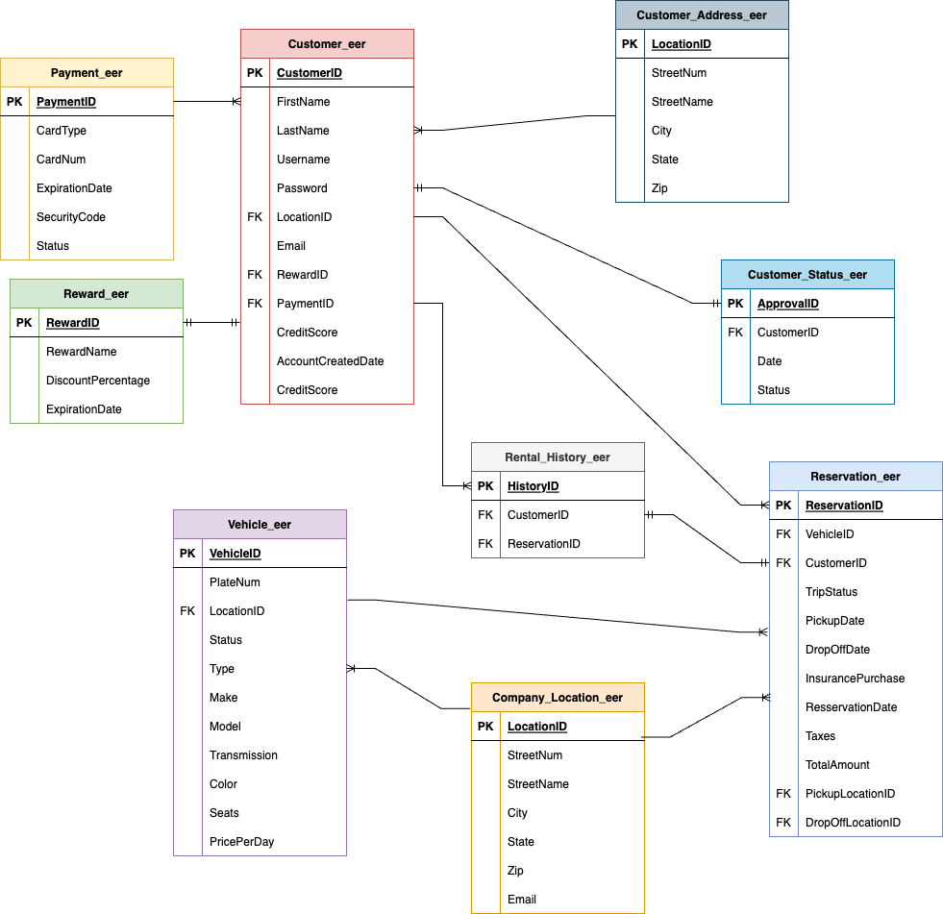

*Note: all tables are suffixed with _eer to clearly distinguish them from other tables that might carry a similar name in the database. See attached file called ‘lauraBuibas_ERDiagram_drawio.png’ for the E-R Diagram image.

1. Database design - see attached file named ‘lauraBuibas_BCS360_DatabaseDesign.pdf’
2. Data- see attached Excel data file named ‘lauraBuibas_BCS360_Data.xlsx’

**Implementation sql logic**

Note: see attached file named ‘lauraBuibas_BCS360_SQL_CODE_FINAL.sql’ for all SQL code.

**Table Creation**

Fig. 1-1 Creating the Customer_eer and Payment_eer tables

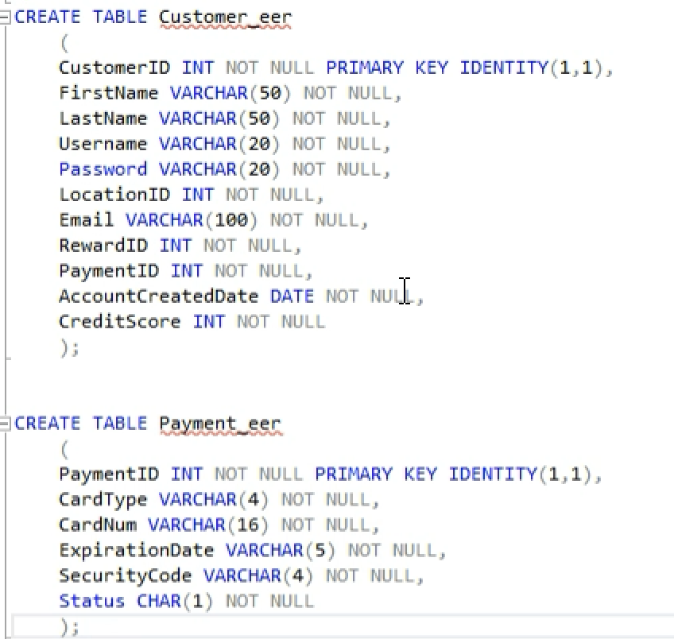

Fig. 1-2 Creating the reward_eer, customer_address_eer, customer_status_eer, and company_location_eer tables

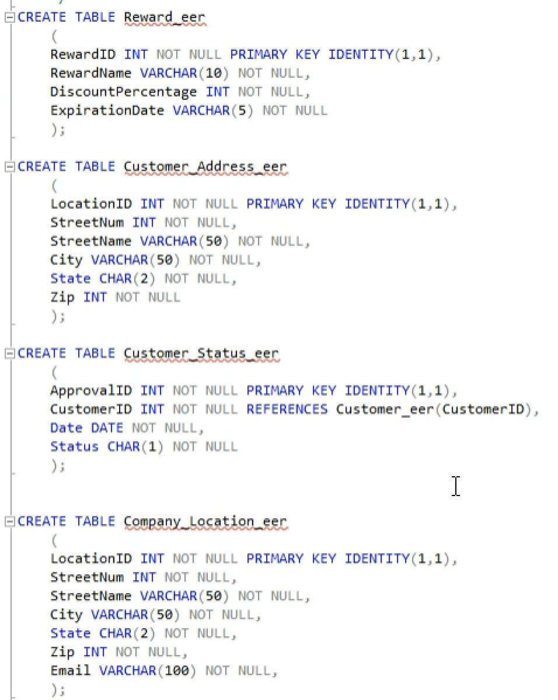

Fig. 1-3 creating the vehicle_eer, reservation_eer, and rental_history_eer tables

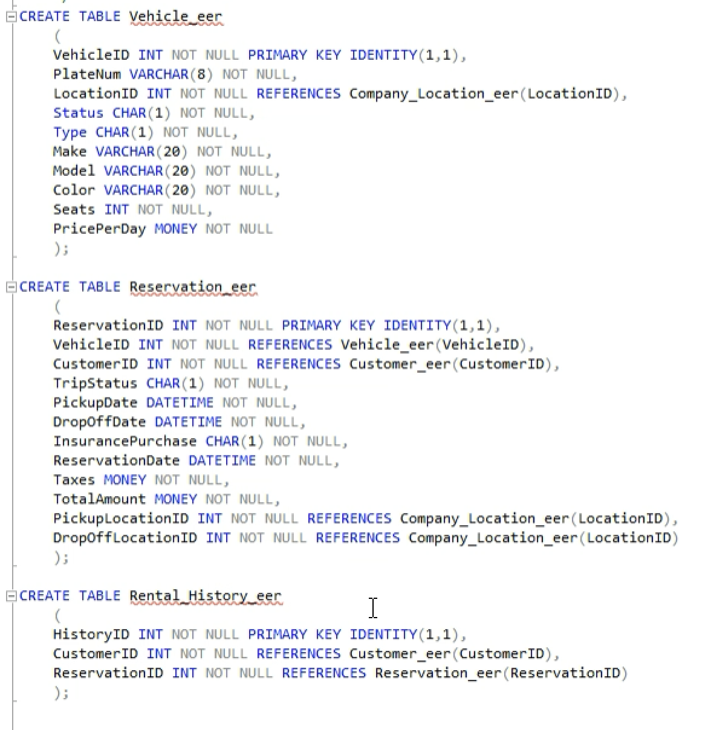

**Inserting Data into Created Tables**

Fig. 1-4 inserting data into the customer_eer, payment_eer, and reward_eer tables

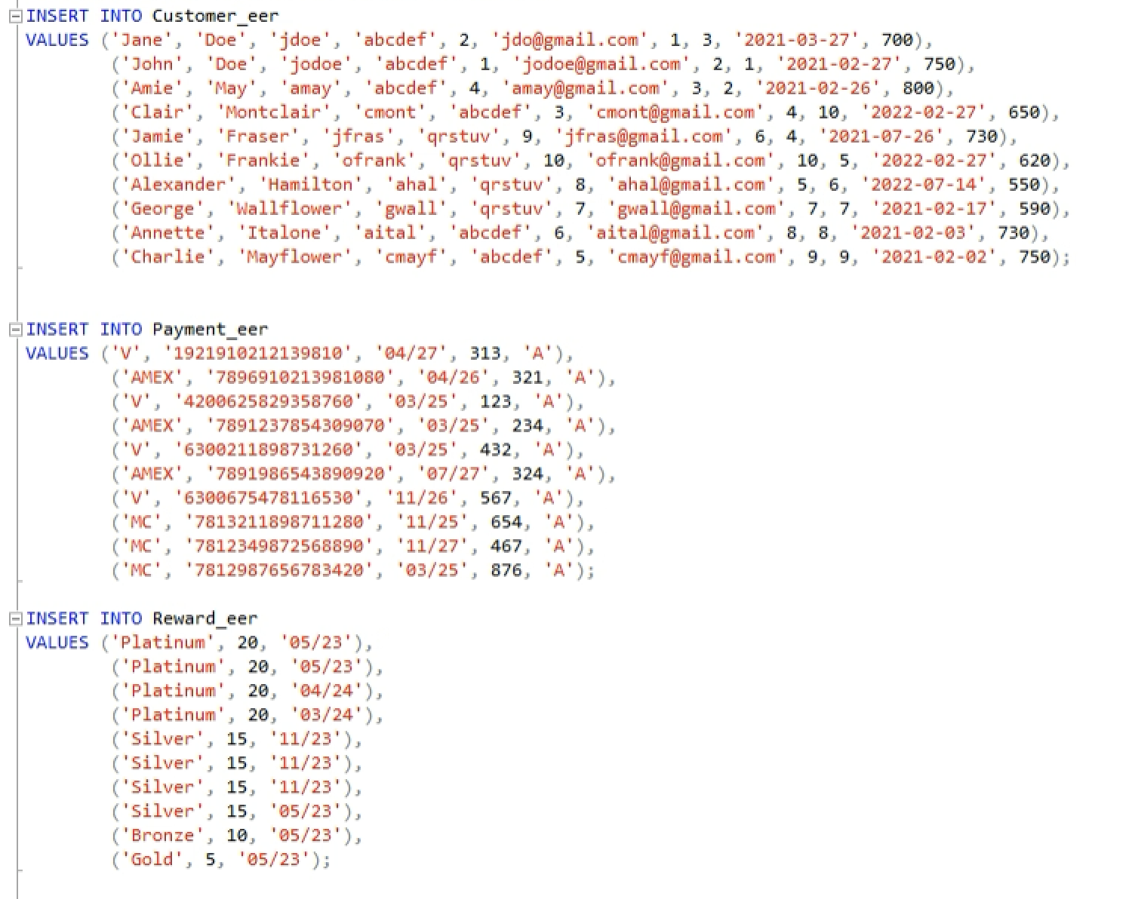

Fig 1-5 inserting data into company_location_eer and vehicle_eer tables

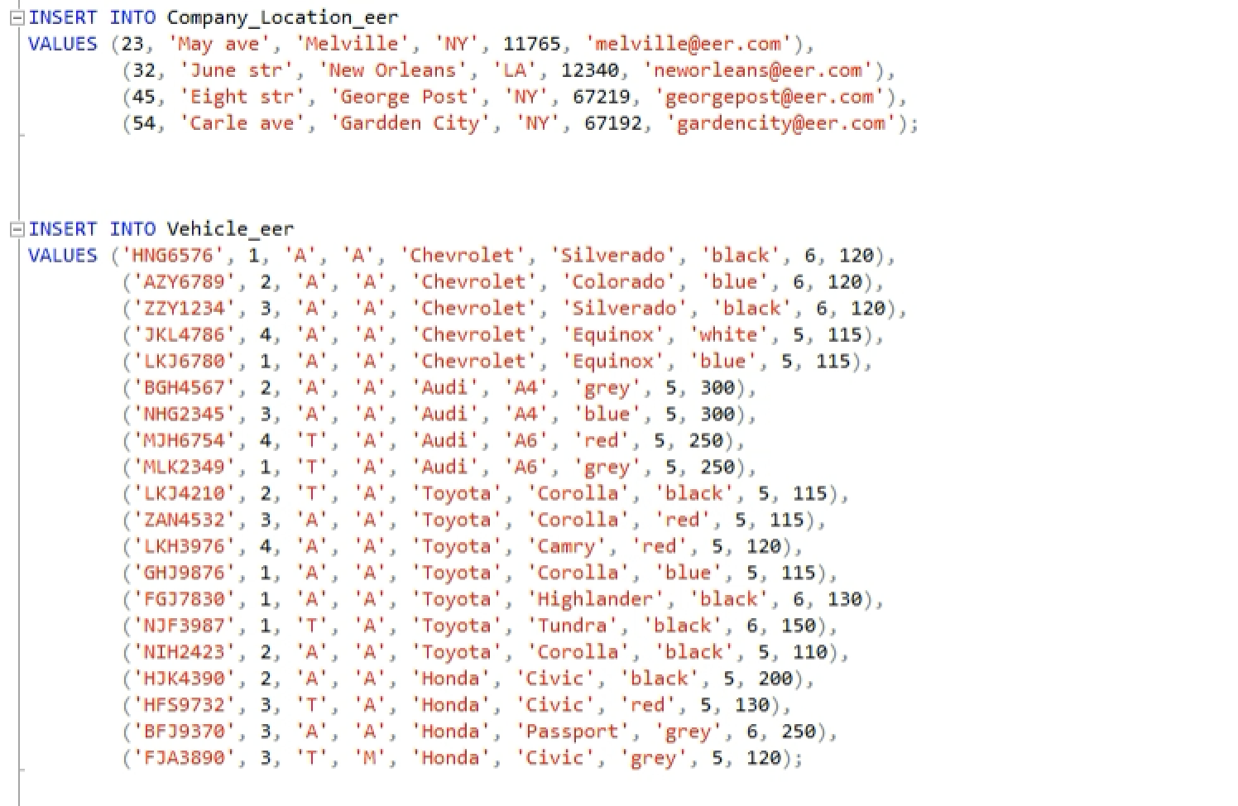

Fig 1-6 inserting data into the reservation_eer and rental _history_eer tables

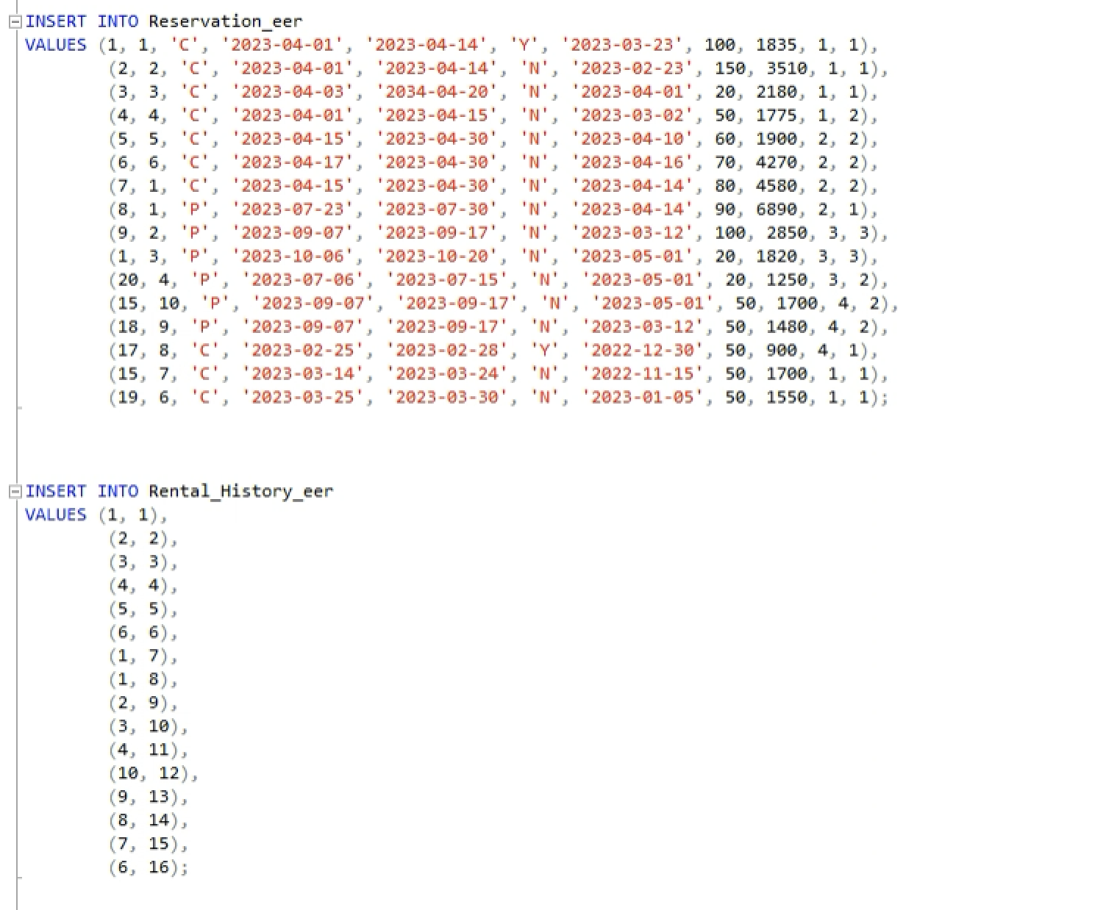

**Database Management and Manipulation Code**

Note: it is strongly recommended to read the next section called ‘Use Cases’ first to understand the purpose of each use case described in this subsection.

Fig. 1-7 the code for the creation of use case 1: customer creates an account

Note: picture extends to the next page

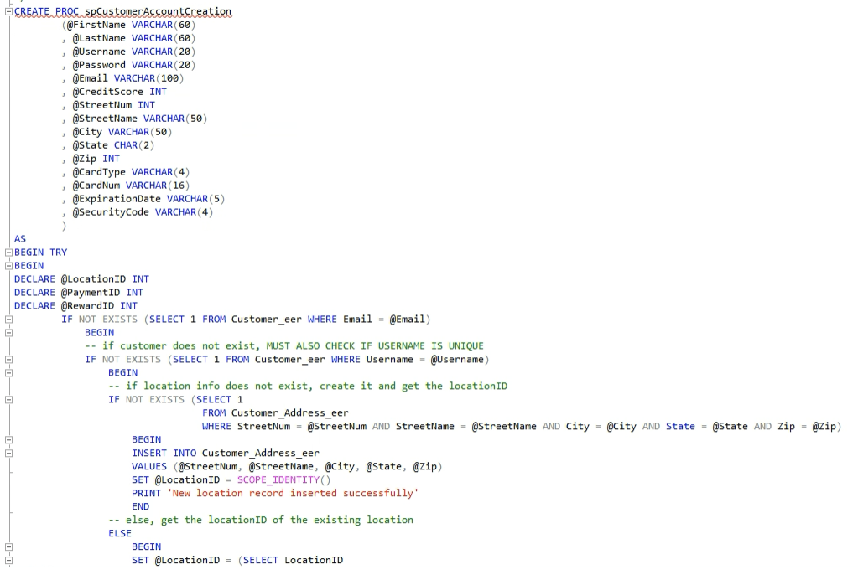

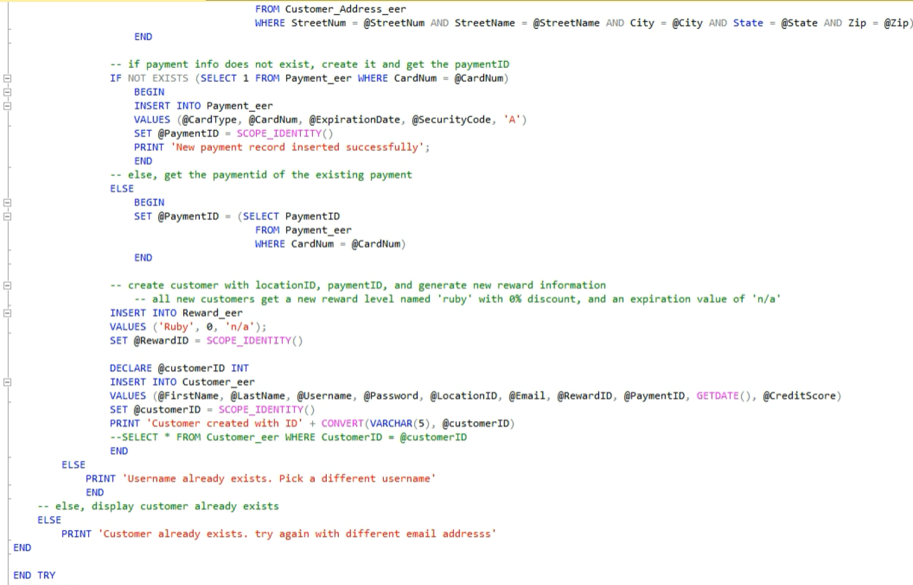



Fig 1-8 the code for the creation of use case 2: upcoming rental management

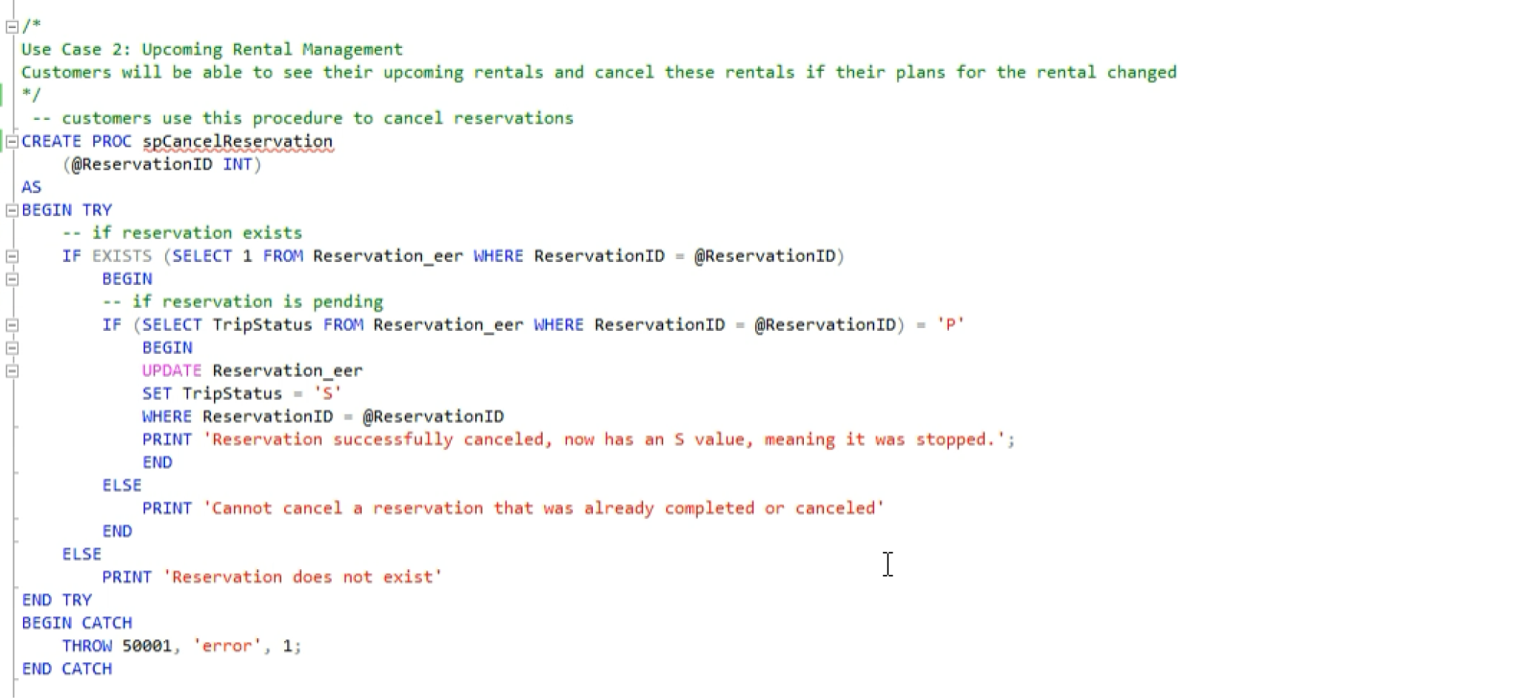

Fig 1-9 the code for the creation of use case 3: vehicle is rented (note: picture extends to the next page)

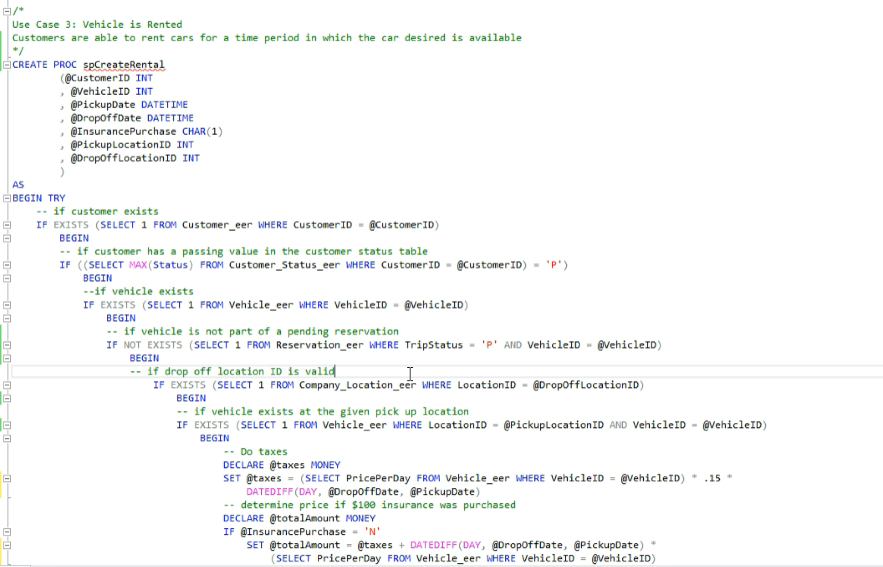

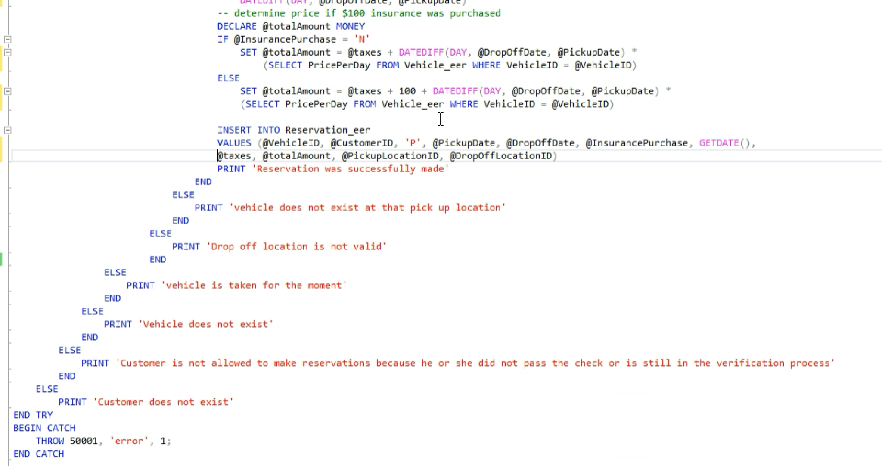

Fig 1-10 the code for the creation of use case 4: available vehicle summary

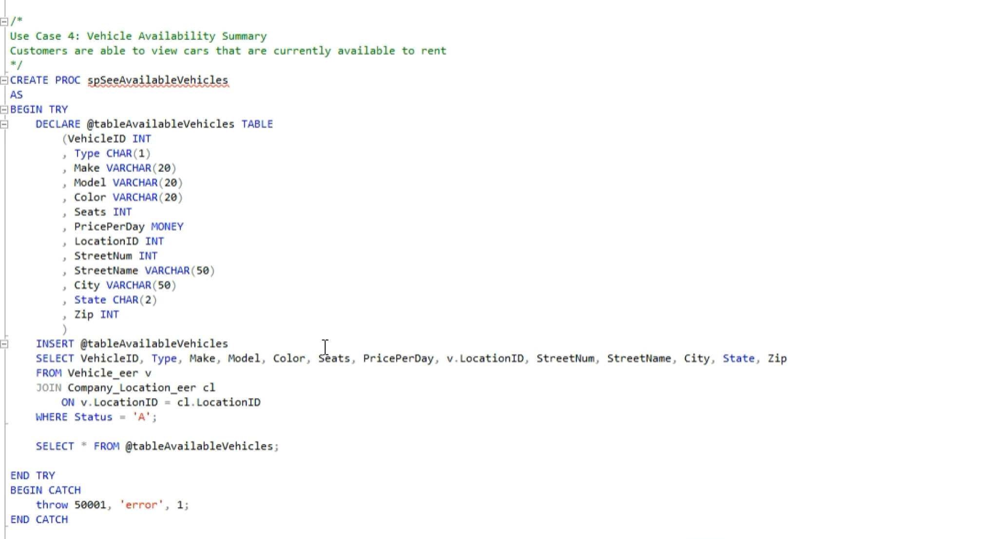

Fig 1- 11 the code for the creation of use case 5: vehicle availability status

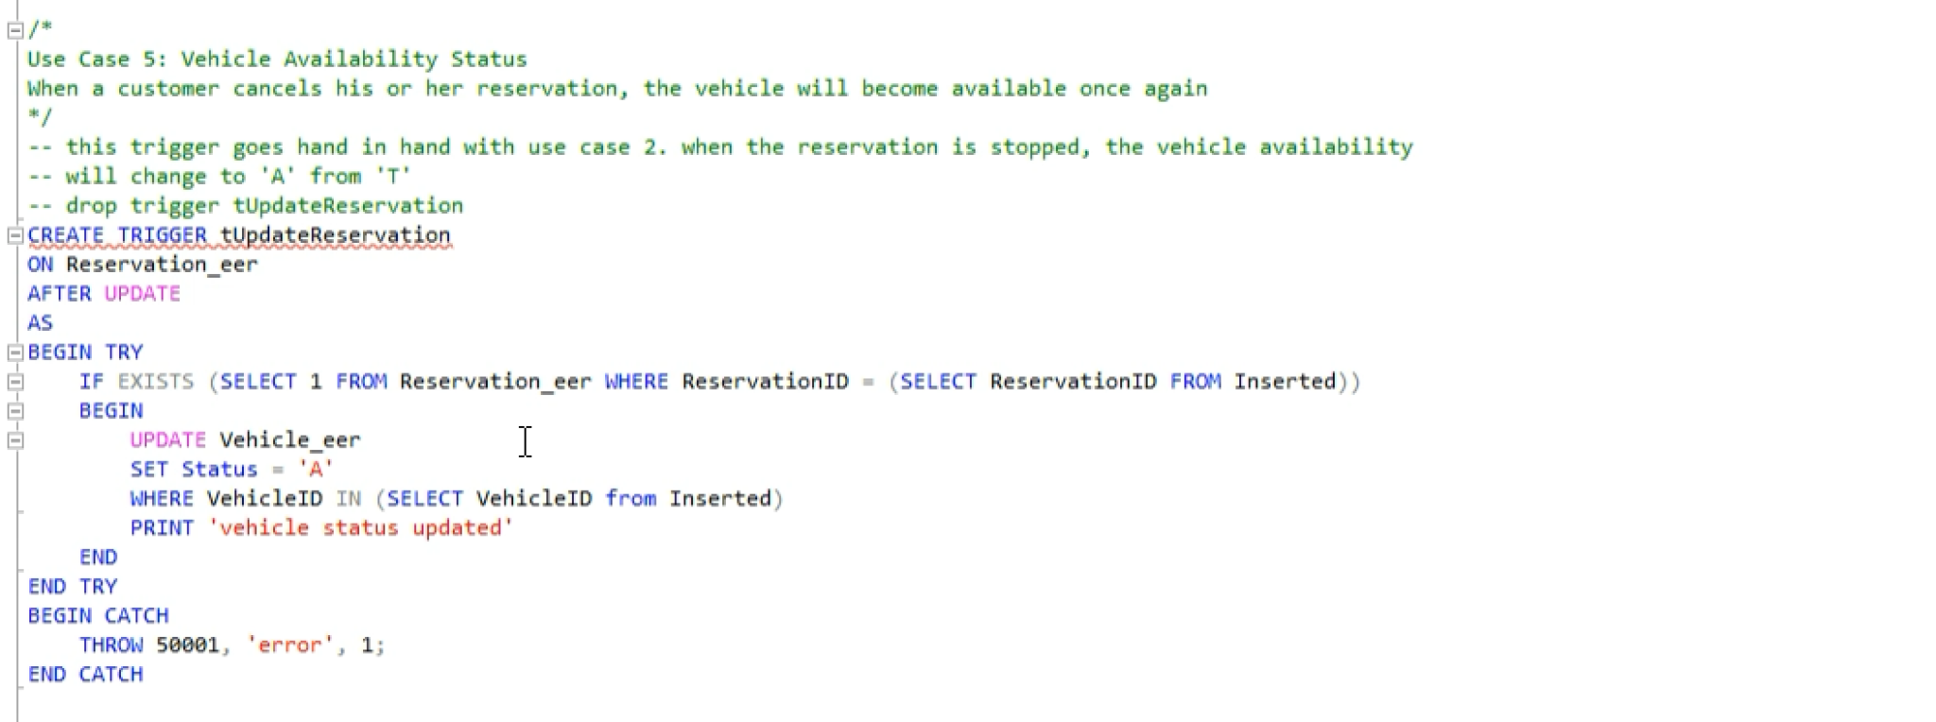

Fig 1-12 the code for the creation of use case 6: vehicle taken status

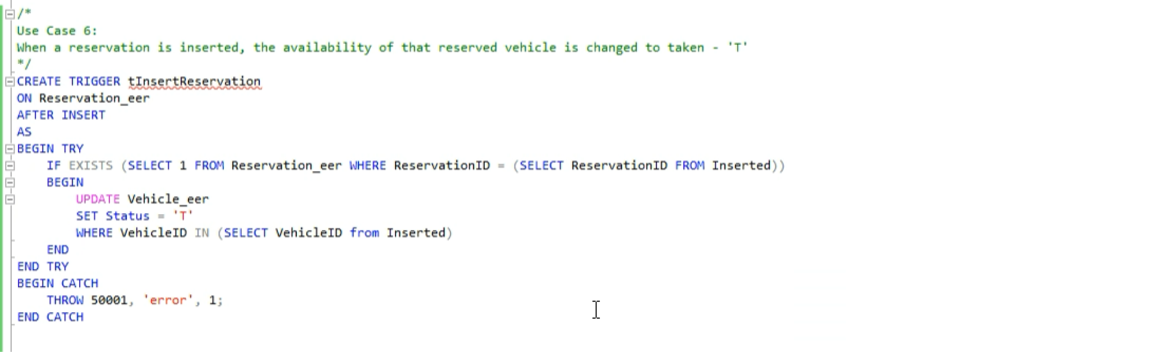

Fig 1-13 the code for the creation of use case 7: see upcoming rentals

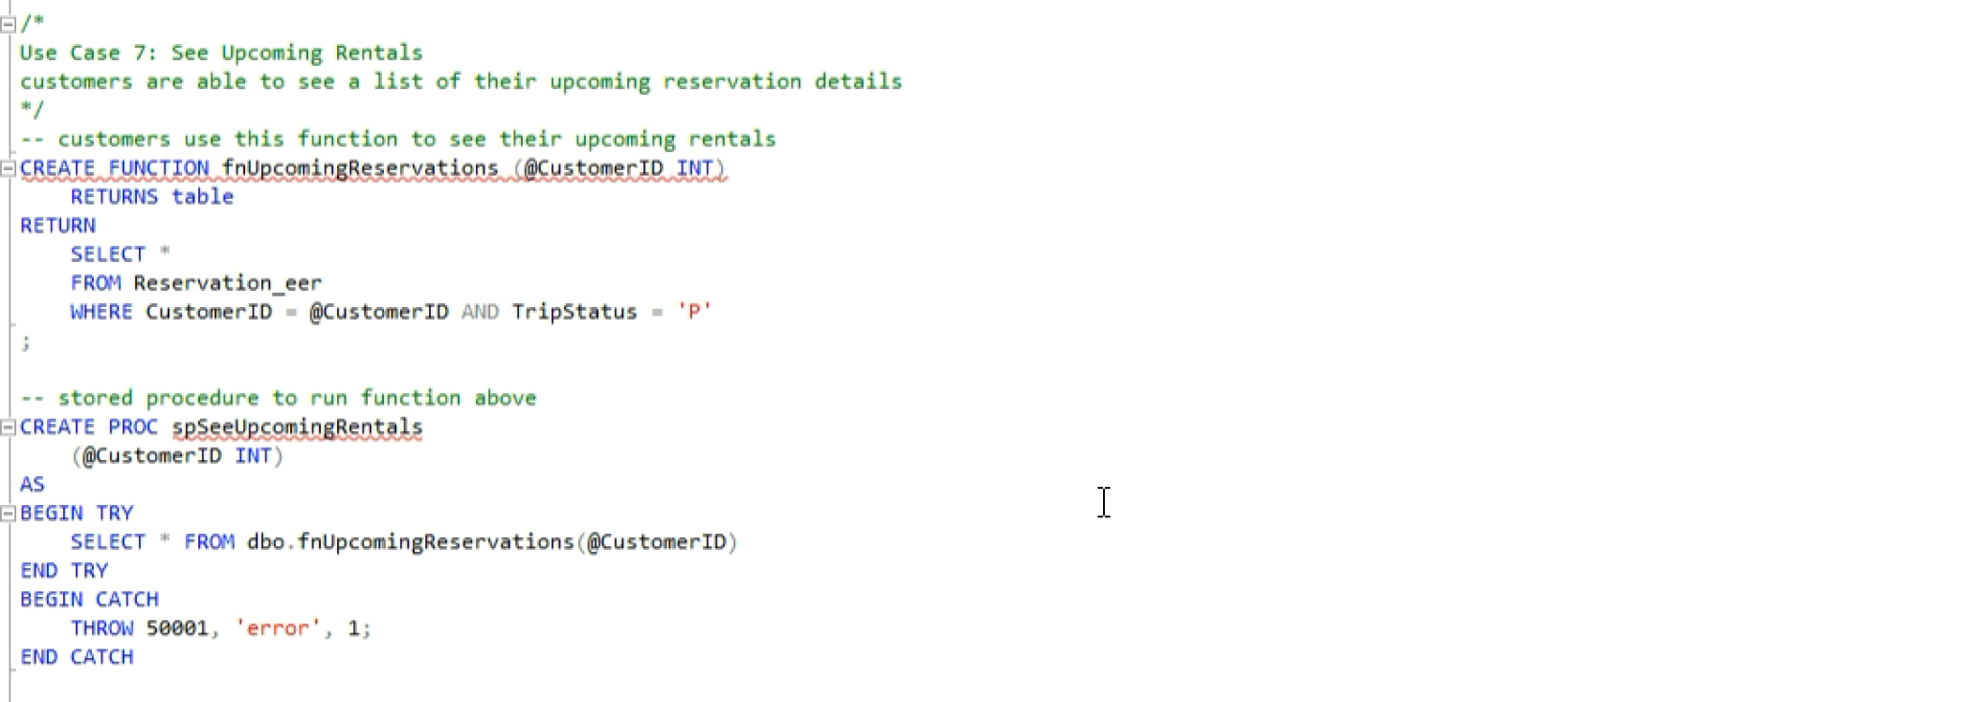

**Use Cases**

**Use Case 1: Customer Creates an Account**

Customers are able to create a customer account using their information. If the fields required are taken by another customer, the customer will be prompted to try again with different information.

In order to create an account, the user must not be an existing customer, must have a unique username, must provide a location, and must provide a payment.

**Use Case 2: Upcoming Rental Management**

Customers will be able to see their upcoming rentals and cancel these rentals if their plans change. Could also be called ‘Upcoming Rental Cancellation’.

The customer will provide an existing reservation whose status is still pending and the reservation will be canceled.

**Use Case 3: Vehicle is Rented**

Customers are able to rent and reserve cars for a time period in which the car desired is available

An existing customer must have a passing value after the credit score check, must wish to rent an existing vehicle that is not currently pending for another reservation and that is available at the specified location. After this, proper money management will be calculated and the reservation will be successfully completed.

**Use Case 4: Available Vehicles Summary**

Users are able to view cars that are currently available to rent

**Use Case 5: Vehicle Availability Status**

When a customer cancels his or her reservation, the vehicle will become available to rent once again.

Everything so far has been a stored procedure, but this will be a trigger that listens for when a reservation is canceled and when it is, the vehicle's status of the canceled reservation will become available ‘A’ once again. This use case goes hand in hand with use case 2.

**Use Case 6: Vehicle Taken Status**

When a reservation is inserted, the availability of that reserved vehicle is changed to taken so that the vehicle cannot be rented by another customer.

This is another trigger that listens for when a new reservation row is inserted, and when it is, the vehicle associated with that particular reservation will have a status that becomes taken ‘T’ so that no other reservations can be made on the upcoming vehicle because it will not show in the table that shows the available vehicles (use case 4). This use case goes hand in hand with use case 3.

**Use Case 7: See Upcoming Rentals**

Customers are able to see a list of their upcoming reservation details by calling a function within a stored procedure.

**Test implementation**

Note: the testing was not done in the order in which the use cases were listed. Instead, testing was done in the order such that use cases can flow into each other.

**The testing of use case 1: customer creates an account**

Fig. 2-1 - Result set if the customer wants to register with an existing email, meaning that the customer already exists.

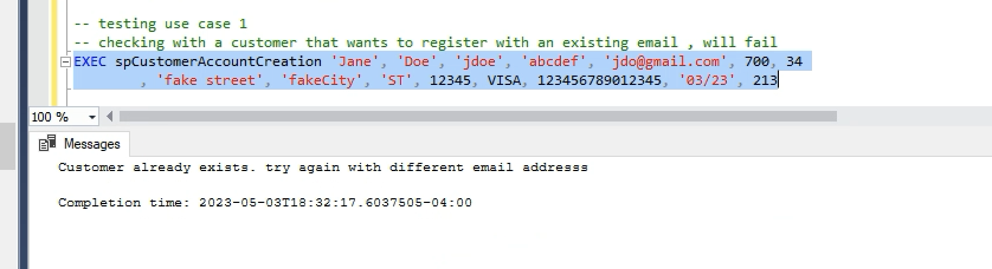

Fig. 2-2 - Result set if the customer wants to register with a new email, but the username is taken by another user

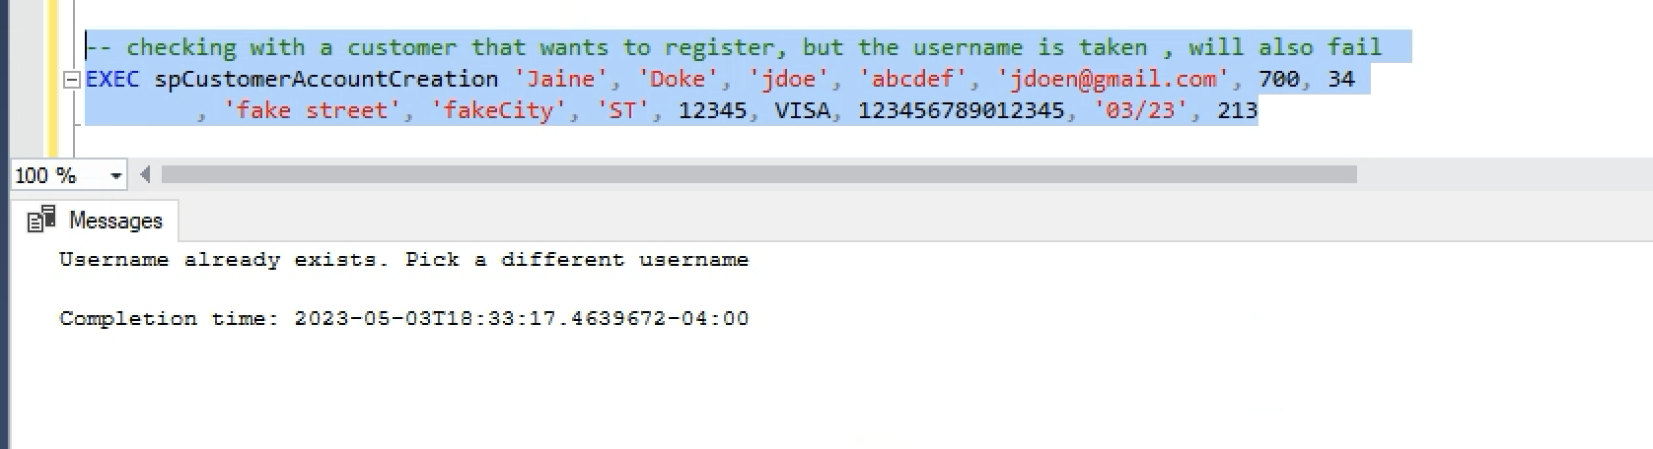

Fig. 2-3 - Result set when the customer wants to register with new email, username, location, and payment information , registration successful 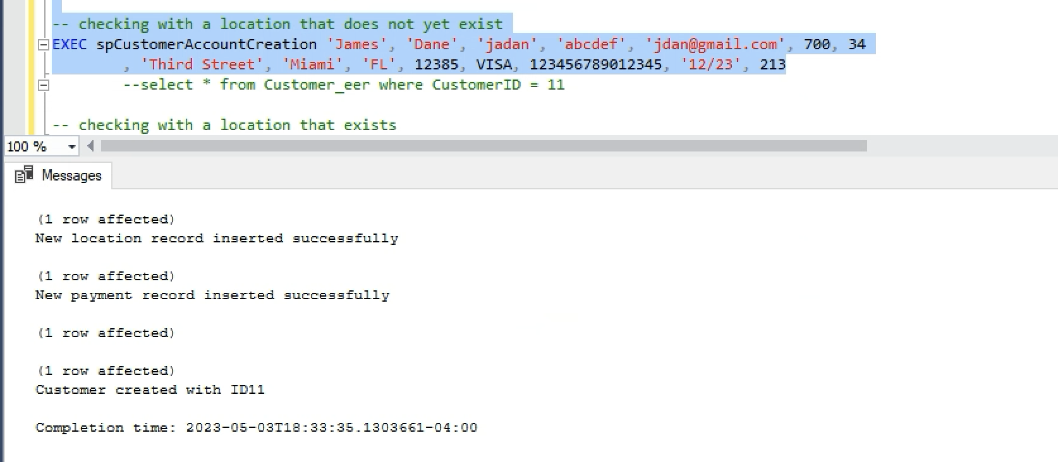

Fig. 2-5 - Result set when registering with a location that already exists, and payment also already exists (reusing some data from the customer in Fig. 2-4), registration still successful

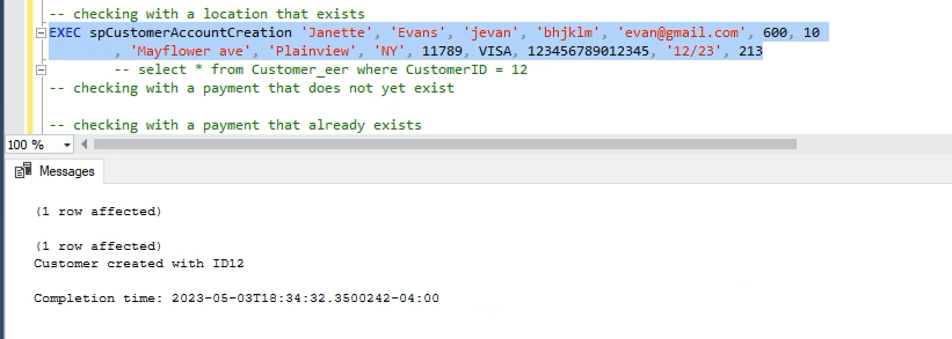

**The testing of use case 4: available vehicles summary**

Fig. 2-7 - Here is a summary of all the vehicles that are available to rent

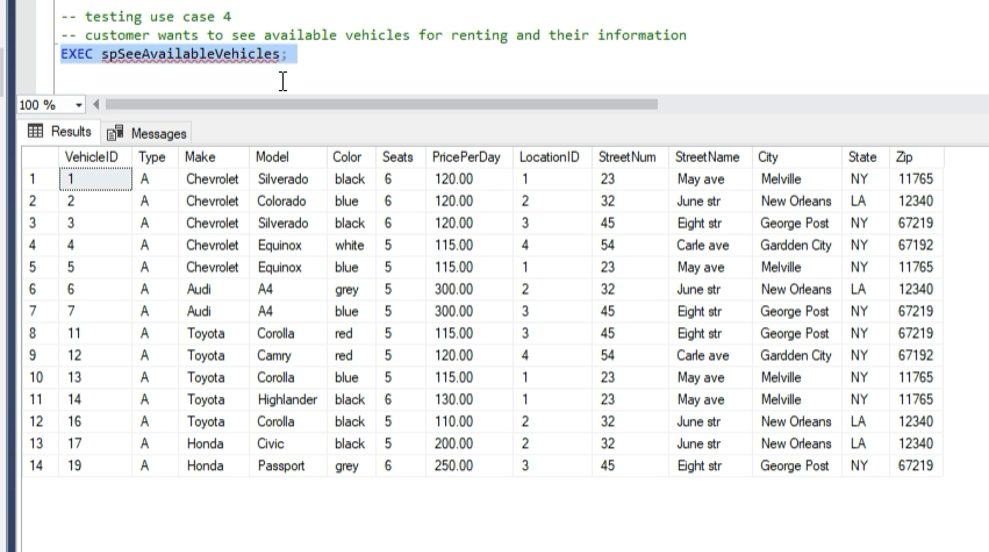

**Testing Use Case 7: See Upcoming Rentals**

Fig. 2-8 - Customers can see details about their upcoming reservations based on their ID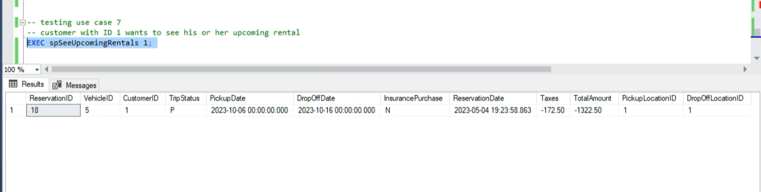

**Testing Use Case 2 : Upcoming Rental Management**

Fig 2-9 - When customers try to cancel an already completed or canceled reservation, a message is displayed saying that such action cannot be taken

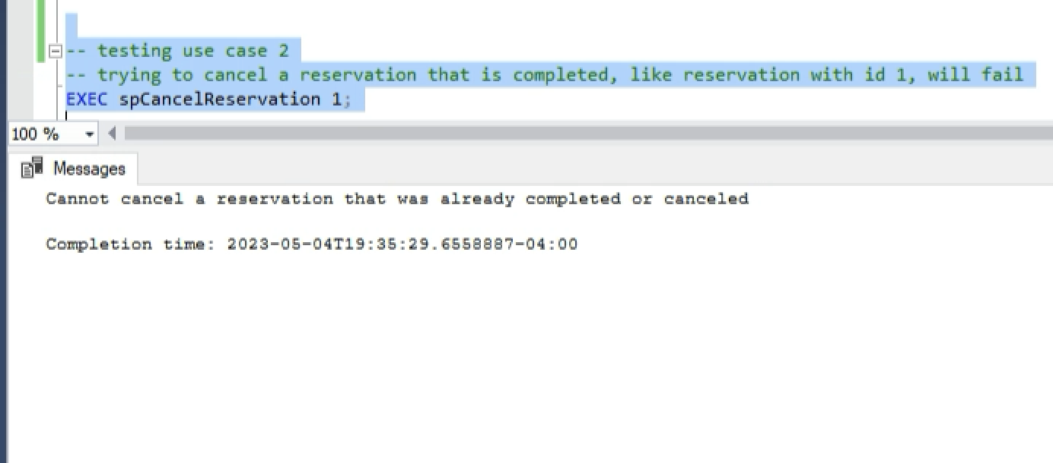

Fig. 2-10 - When a customer tries to cancel a reservation that is currently in the pending process, the value of the reservation changes to ‘S’ meaning the reservation was stopped, and thus, successfully canceled.

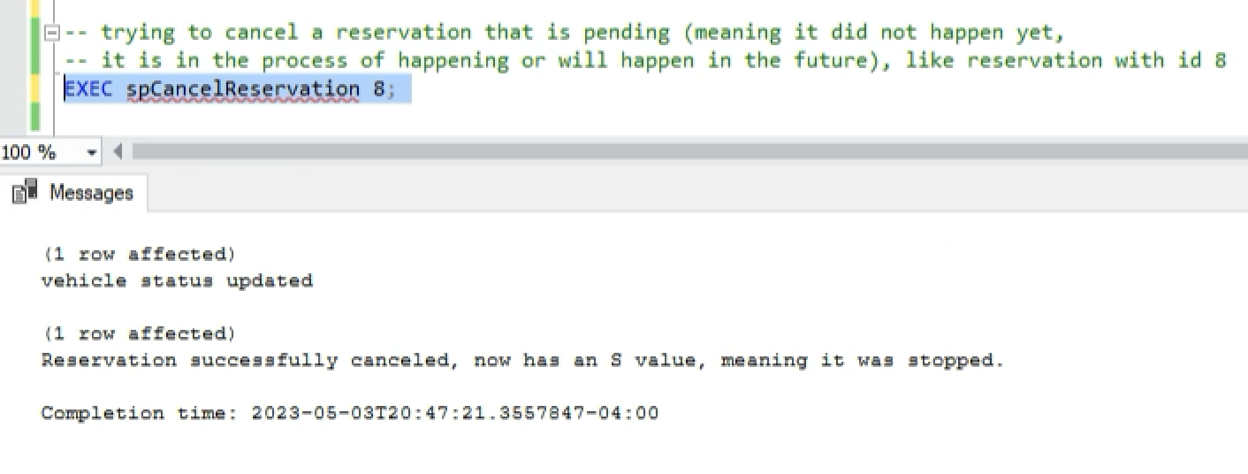

**Testing Use Case 5: Vehicle Availability Status**

Fig. 2-11 - once a reservation was successfully canceled, the vehicle status that was assigned to that reservation is changed to available - ‘A’ - and its presence can be seen through the stored procedure that shows the available vehicles.

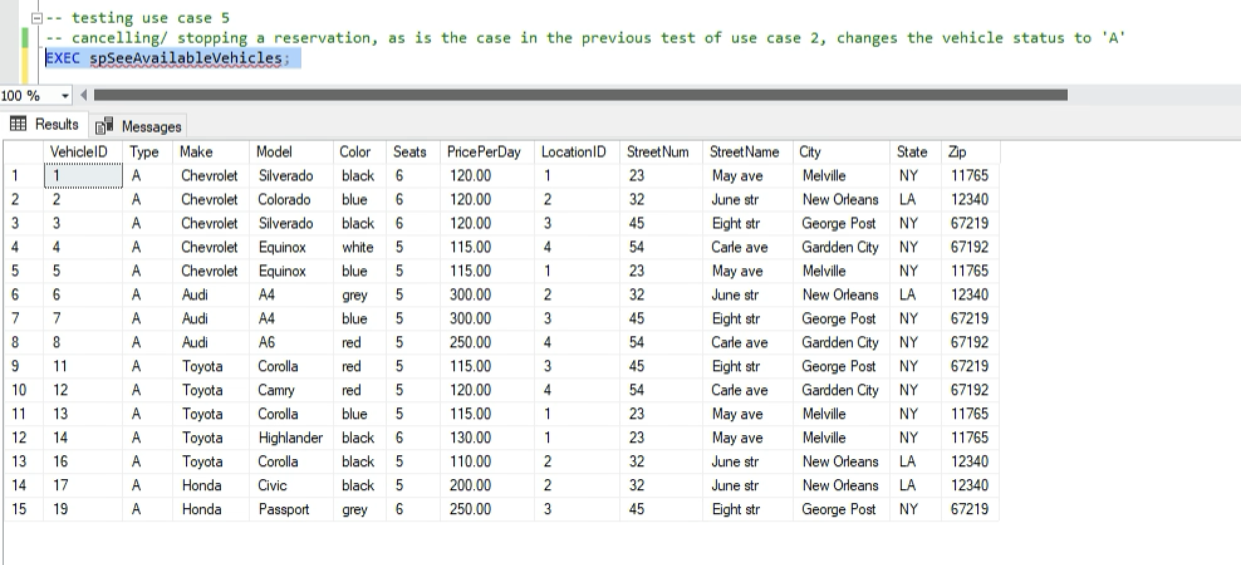

**Testing Use Case 3: Vehicle is Rented**

Fig. 2-12 Trying to rent a vehicle in which the user does not exist results in a message that shows the issue.

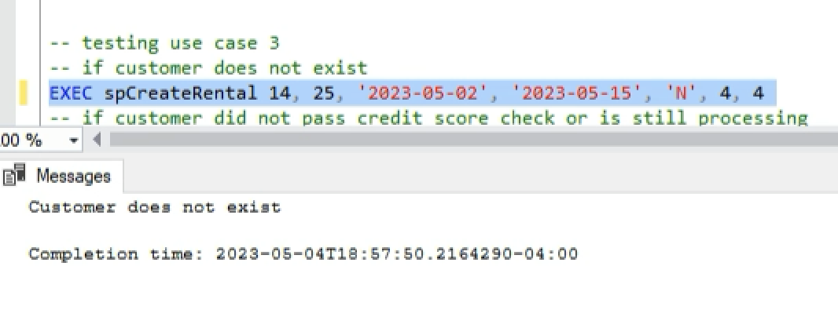

Fig. 2-13 - if the customer wants to rent a vehicle that is taken by someone else in a pending reservation, a message is printed saying that the vehicle is taken

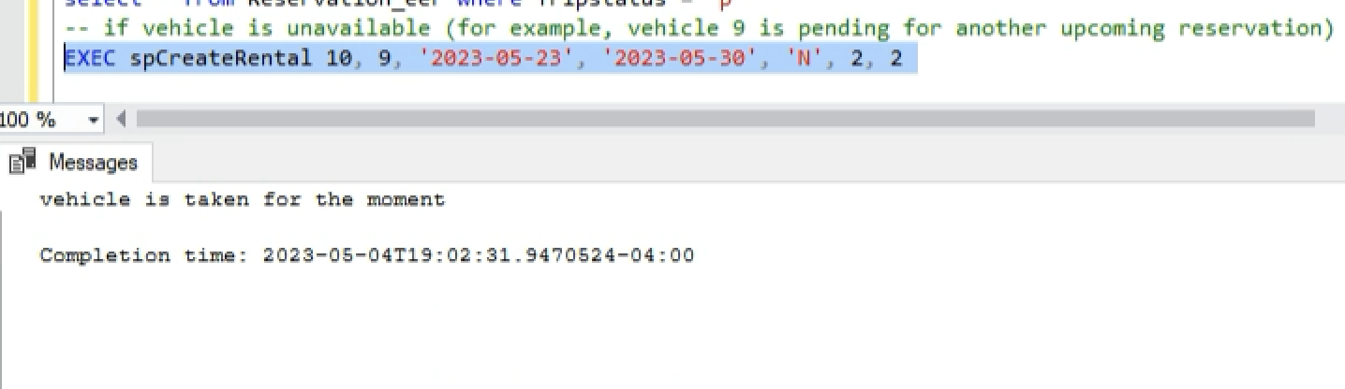

Fig. 2-14 - if the customer wants to rent a vehicle that does not exist at a location, it prints a message

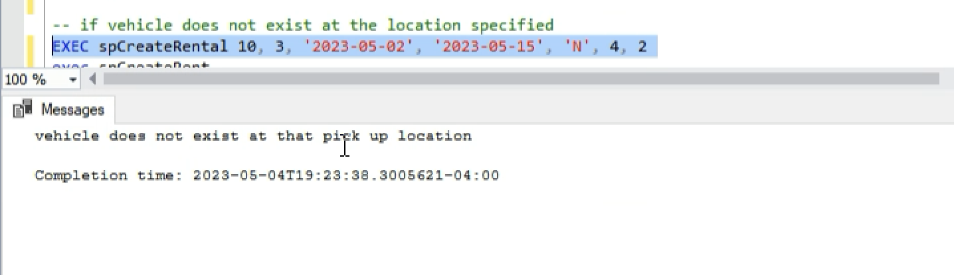

Fig. 2-15 - if the customer successfully creates a reservation, it tells the user that the reservation was made.

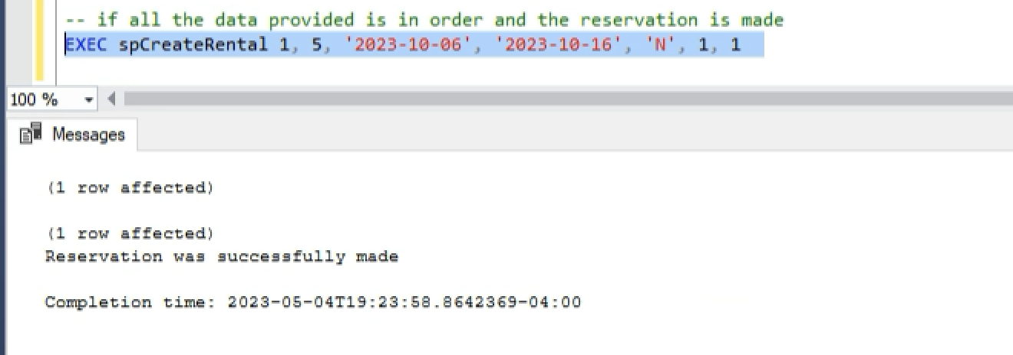

**Testing Use Case 6: Vehicle Taken Status**

Fig. 2-16: After a reservation was made, the status of that vehicle is changed to ‘T’ meaning ‘taken’, as is the case with the vehicle with ID 5 from the previous example, and will thus not be shown in the stored procedure that displays the available vehicles and their information

